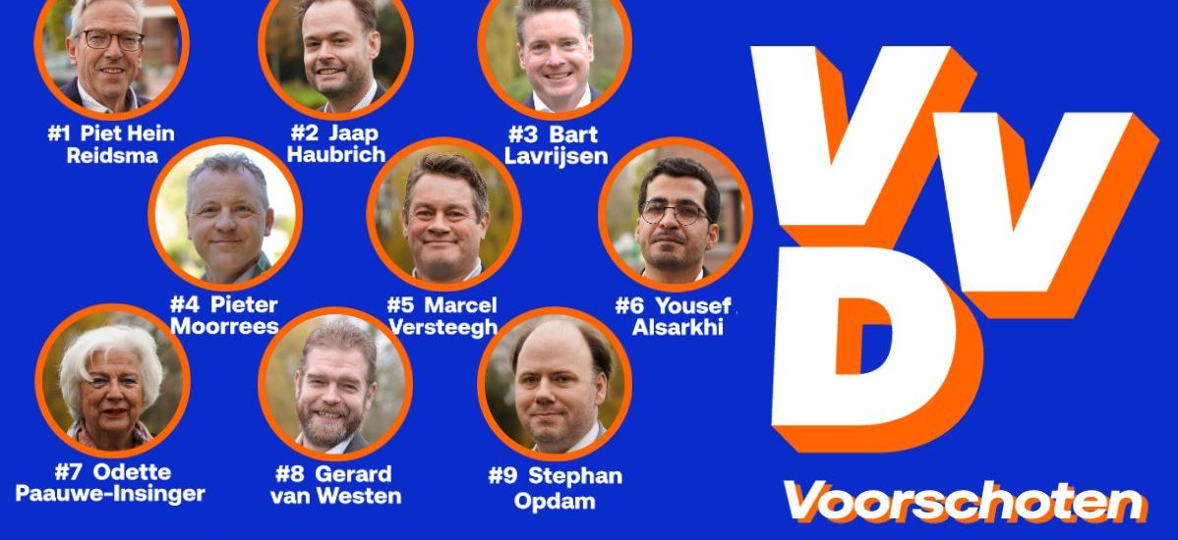

Information for British Residents in the Netherlands
As a British citizen living in the Netherlands, you have the right to take part in the municipal elections. This voting right applies to all citizens of the European Union who are officially registered as residents in a Dutch municipality.
The next municipal elections will take place on 18 March. By voting, you can have a say in local decision-making and the future development of your municipality.
“Voorschoten Safe Village” is the name of the election program with which the VVD is entering the municipal elections in March 2026. The party is pleased with what has been achieved in recent years. A vibrant town center with many events, a rich community life, and numerous facilities ensure that people enjoy living in the village.
Building and Accessibility
The VVD has contributed to the realization of housing projects, such as those completed at Fortuyn and Berensteyn. In addition, construction is underway on Einsteinlaan. Accessibility has improved through the completion of the Corbulo Tunnel and by limiting disruption during the modifications at Lammenschansplein. Thanks to questions raised by our council group, a separate bicycle bridge will be built so that our secondary school students can travel to school safely during the construction works. In cooperation with the VVD group in the province, VVD Voorschoten has worked to ensure that the road to Leidschendam was repaired.
Safety
Important steps have been taken in the field of safety. The roundabout in front of the town hall has been renovated, making it significantly clearer and safer. Cable channel tiles have been made available to allow cars to be charged safely, and considerable attention has been given to safety at the railway stations. Recently, funds have also been allocated to improve enforcement in the business parks.
Sports Facilities
Our love of sport has led to a sports facilities policy that ensures a level playing field for all associations. It is now clear which maintenance responsibilities fall to the municipality. A new athletics track is the result, and work is underway on the construction of a new sports hall and a swimming pool.
Future
The new election program sets out how the VVD intends to continue and strengthen the positive developments. Key themes are safety, the economy, and housing construction.
Increasing Safety
In the area of safety, the VVD wants to make more funding available to enhance security. Safety around the railway stations must be improved, as well as in the town center. The VVD also wants stricter enforcement in the business parks.
Strengthening the Economy
The town center must continue to grow as an attractive meeting place, with room for entrepreneurs. The economy in Voorschoten must truly move forward: more investment is needed to improve the town center. In the Dobbewijk area, more space must be created for entrepreneurs who want to expand or establish themselves. Funds should also be available to organize activities that contribute to the local economy. Affordability is important for everyone: that is why the VVD is actively committed to preventing any further increase in property tax (OZB).
Continuing to Build
The housing shortage in Voorschoten is significant, and building according to demand is essential for the VVD. The implementation of construction projects such as those at Jan Evertsenlaan and Jan Wagtendonkstraat must be accelerated. Raadhuislaan and Oude Stationslaantje will also be developed in the coming period. The housing projects Segaar-Arsenaal and Starrenburg 3 must be completed within the next four years.

